Bingo Player API Review

API

1. Manage player

Player JOIN to existing session

Player supply: game0id, session-id, nick-name

The sending param does not affect this API, no data is added to server

Do nothing weather we send user details or not showing data same as was before

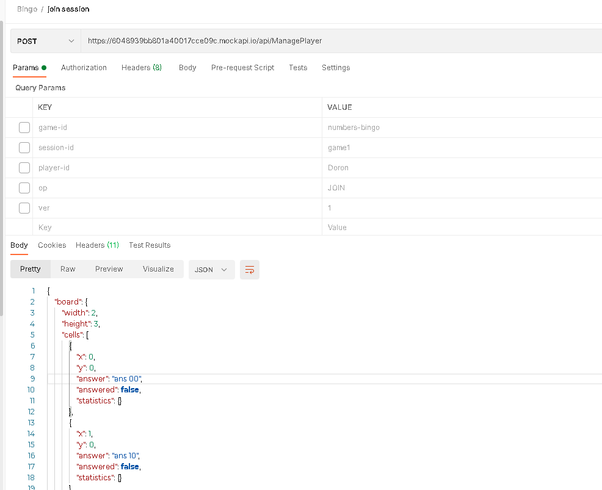

* should be able to receive “answered”:true and in such case, the cell should be displayed as answered

submit answer API not working so the answered is always false

1. BingoAnswer

A “BingoAnswer” POST request is sent as follows:

The API does not affect anything weather we send data or not

Also the param should not be in different format like for user details you are sending in query params and for answer data you are using raw json

Everything should be in one format you can use form data or json (one format thing at a time)

Like json could look like this:

{

“game-id”:” numbers-bingo”,

“session-id”:” game1”,

“player-id”:” Doron”,

“op”:” JOIN”,

“ver”:”1”,

"x":0,

"y":0,

"answer":"18"

}

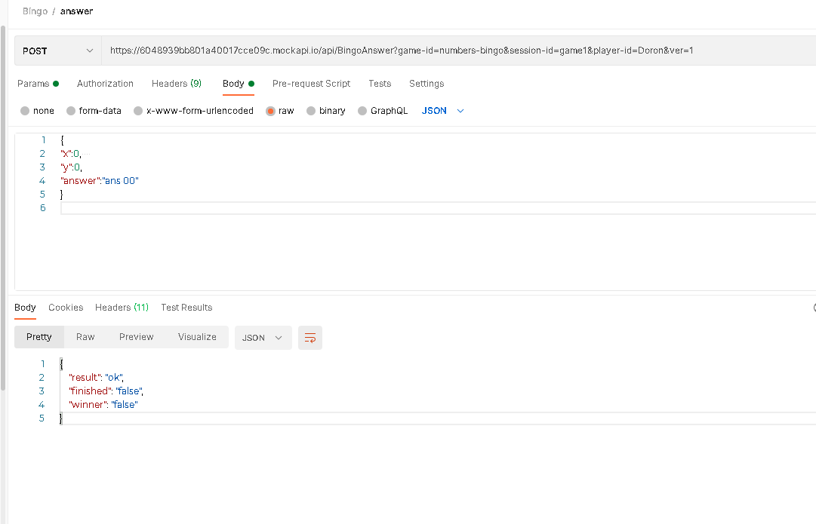

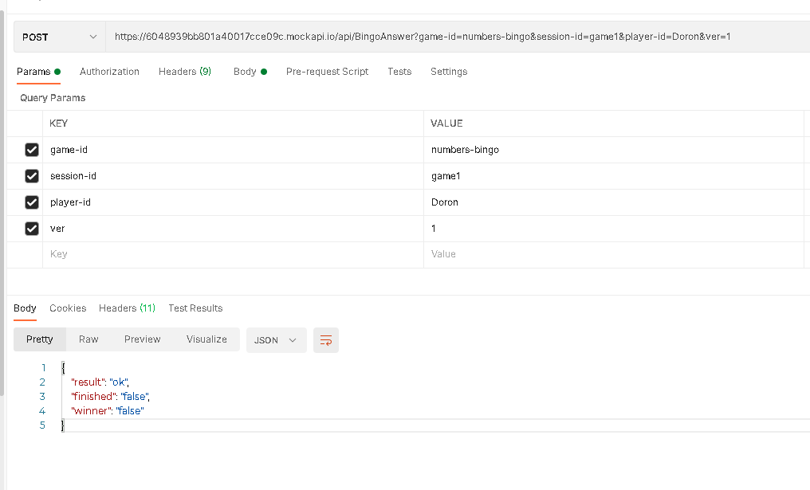

There are two types in one request. Always add headers or send data in one form

Also attach all response for success and failure so we can handle depending on requests

Cell should be colored and disabled, like “answered=true of the above ManagePlayer

Yes the cell could be colored but data should be provided according to player id currently there is not such data

More updates:

The existing sessions are removed

The player fields are added

The cells size is increased

“Join session” instead “New Session”

